ShopEZ - Full-Stack E-Commerce Web Application
INTRODUCTION:
ShopEZ is a responsive e-commerce web application that provides customers with a single place to discover products, inspect specifications, search and filter the catalog, manage a shopping cart, apply coupon discounts, and review order information. The interface is built as a React single-page application, while an Express REST API handles account, product, coupon, order, and analytics operations.
The project follows a decoupled client-server design using React, Node.js, Express.js, MongoDB, and Mongoose. Its interface uses Vite, Tailwind CSS, reusable React components, and shared context for authentication, cart calculations, and notifications. A browser-based interface serves customers, while a role-protected administration console provides product and order management features.
The provided evidence records eight seeded catalog products, customer and administrator demo accounts, coupon validation, order history, product management, and order status updates. Payment processing is simulated rather than connected to a third-party payment gateway. The report describes the application using the supplied technical audit, test log, source-structure inventory, and live-browser screenshots.
Project Overview
• Project Name: ShopEZ (ShopEZ E-Commerce Web Application)
• Application Type: Full-stack, responsive e-commerce website
• Primary Stack: React + Vite frontend; Node.js + Express backend; MongoDB with Mongoose
• Repository: https://github.com/gopaljamadar70-sudo/ShopEZ-Ecommerce

SCENARIO BASED CASE STUDY:
Background
An online store needs to make product discovery and purchasing convenient while giving store staff a practical way to maintain the catalog and process orders. Customers expect product descriptions, prices, stock information, search, a cart, discounts, and a clear view of their previous purchases. Administrators need controlled access to inventory and order operations without exposing those capabilities to ordinary customers.
Scenario
A customer visits ShopEZ to find an item, compare its price and details, add it to a cart, and continue through the checkout workflow. A returning customer signs in to view order history or update profile information. An administrator enters a protected management console to review store metrics, create or remove products, and change order fulfillment statuses.
The Challenge
A useful store must coordinate several connected tasks: consistent catalog information, accurate cart calculations, secure account access, coupon validation, stock-aware order placement, and clear separation between customer and administrator privileges. These tasks should work within a responsive interface that remains easy to browse on different screen sizes.
How ShopEZ Addresses the Scenario
• Catalog discovery: Category filters, keyword search, product cards, and detailed product pages.
• Shopping workflow: A cart with quantity controls, discount validation, shipping details, and payment-method selection.
• Account services: Registration, login, profile management, and customer order history.
• Administration: Role-based controls, product CRUD operations, order status management, and dashboard KPIs.
The supplied audit reports that the main API flows and a 24-test automated suite passed. However, the checkout and order-confirmation browser captures show an empty checkout state and a loading indicator; these particular visual outcomes are documented later as capture limitations rather than presented as successful screenshots.

SYSTEM REQUIREMENTS:
1. Software Requirements
The following tools and versions are recorded in the supplied ShopEZ technical evidence. Versions can vary between development environments; the project package files and lockfiles should be treated as the source of truth when reinstalling dependencies.
• Operating System: Windows 10/11, macOS, or a modern Linux distribution.
• Node.js and npm: Node.js runtime with npm for installing and running the frontend and backend. The audit records Node.js v24.22.0 in its tested environment.
• Frontend: React 18.3.1, Vite 6.x, Tailwind CSS 3.4.17, PostCSS, Autoprefixer, and lucide-react.
• Backend: Node.js, Express.js 4.21.2, dotenv, morgan, helmet, cors, jsonwebtoken, and bcryptjs.
• Database: MongoDB with Mongoose 8.9.5; mongodb-memory-server is included as a local fallback when an external MongoDB URI is not configured.
• Testing and Browser: Vitest 3.2.7 and a modern browser such as Chrome or Edge. Postman or equivalent tooling can be used for additional API checks.
• Editor and Version Control: Visual Studio Code or another code editor; Git for source control.
2. Hardware Requirements
• Processor: A modern dual-core processor or better; a recent Core i3/Ryzen 3 or higher is recommended for smooth multitasking.
• Memory: At least 4 GB available RAM is recommended; 8 GB or more is preferable when the editor, browser, and both development servers run together.
• Storage: Allow at least 1 GB free space for the project, npm packages, build output, and local database cache. Actual package size depends on installed dependencies.
• Display: A 1366 × 768 or higher desktop display for development and browser testing; responsive behavior should also be tested at mobile widths.
These hardware values are practical development recommendations, not strict application-enforced limits. For a deployed environment, configure production database storage, secure HTTPS, secrets, monitoring, and an appropriate server resource budget.

TECHNICAL ARCHITECTURE:
Technical Architecture Overview
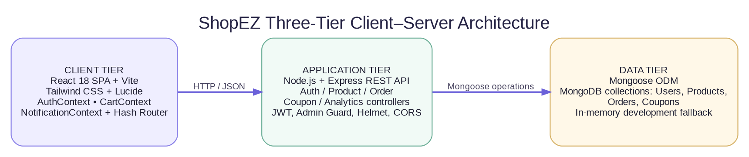
Figure 1. ShopEZ decoupled client-server architecture based on the supplied technical report.
Client tier: React renders the user interface in the browser. Vite provides the development/build toolchain; Tailwind CSS handles styling, and Lucide icons provide interface symbols. AuthContext, CartContext, and NotificationContext share authentication, cart, and notification state. The application uses a custom hash-based router.
Application tier: The Express REST API runs on the backend and groups business operations into authentication, product, order, coupon, and analytics controllers. Helmet, CORS, authentication middleware, administrator role checks, request logging, and centralized error handling support request processing.
Data tier: Mongoose provides schema-based access to MongoDB collections for users, products, orders, and coupons. The supplied configuration also supports mongodb-memory-server when no external MONGO_URI is configured, simplifying local development and automated tests.
Requests move from the browser to the REST API as HTTP requests carrying JSON. Protected routes use a Bearer JWT. Controllers validate inputs and carry out database operations through Mongoose, then return JSON responses to the frontend. This separation allows the interface and API to evolve independently.

ER DIAGRAM:
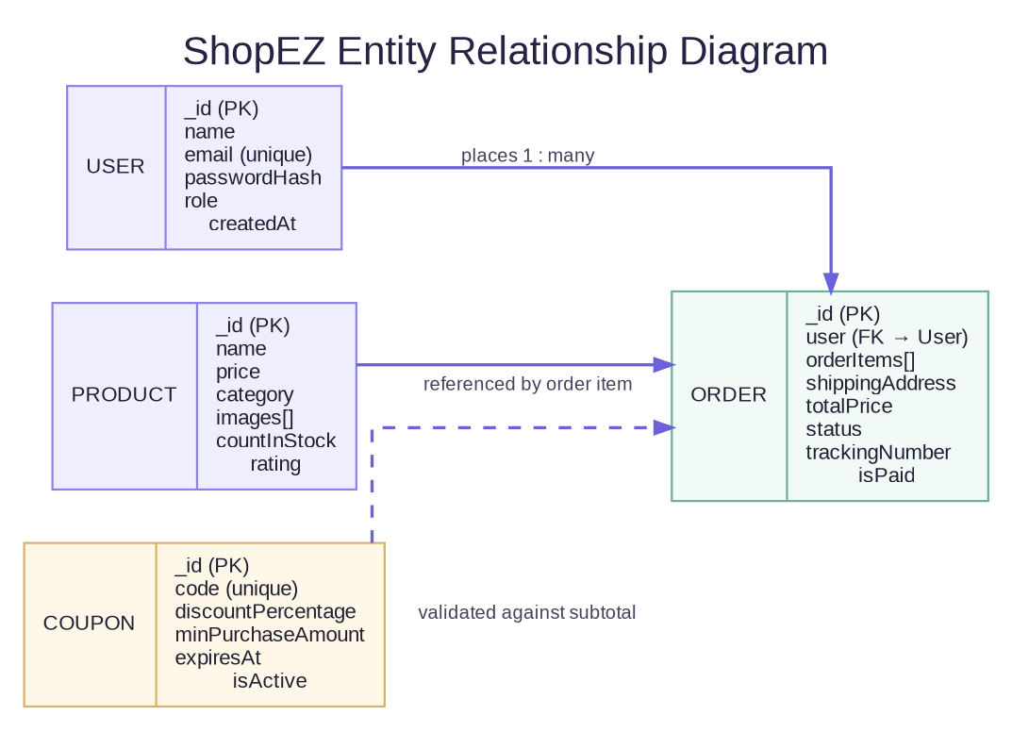
Figure 2. Main data entities and relationships represented in ShopEZ.
Entities and Relationships
• User: Stores the customer or administrator identity, name, unique email, hashed password, role, and creation timestamp.
• Product: Stores product name, description, price, category, image URLs, stock count, rating, review count, and featured status.
• Order: References the user who placed the order and stores order items, shipping address, payment method/result, prices, payment flag, fulfillment status, and tracking number.
• Coupon: Stores a unique coupon code, discount percentage, minimum purchase amount, expiry, usage limit, number of uses, and active flag.
Each user can have multiple orders. An order contains an array of item subdocuments that refer to products. Coupon rules are validated against the cart or order subtotal; the supplied evidence describes coupons as independent promotional rules rather than a required direct foreign-key relationship.

KEY FEATURES:
1. User Management
• Registration and Login: Creates customer accounts, validates credentials, hashes passwords with bcryptjs, and issues JWT tokens.
• Profile Management: Allows authenticated customers to update personal details and delivery information.
2. Product and Catalog Management
• Catalog Browsing: Product cards and category filters organize the seeded catalog into categories such as Electronics, Fashion, Audio, Wearables, and Gaming.
• Search and Product Details: Keyword search filters products; detail views show descriptions/specifications, ratings, stock information, images, price, and an Add to Cart action.
• Administration: Authorized staff can create and delete products, review product inventory, and work with order fulfillment controls.
3. Cart, Coupons, and Checkout
• Cart Controls: Customers can adjust quantities, remove items, view line totals, and see calculated cart amounts.
• Coupon Validation: The reported coupon engine supports WELCOME10 and SAVE20, subject to minimum-purchase thresholds.
• Checkout Workflow: The UI provides shipping-address fields and payment-method selection. Payment behavior is simulated; there is no verified live Stripe/Razorpay integration.
4. Orders and Store Analytics
• Order History: Customers can review prior orders and associated statuses or tracking identifiers.
• Admin Dashboard: The console displays store KPIs such as revenue, order counts, product counts, and customer counts.
The supplied test log records coverage for authentication, duplicate registration prevention, access protection, catalog retrieval, admin product CRUD, orders, coupon validation, and analytics. Visual evidence for each screen is provided in the final section of this report.

ROLES AND RESPONSIBILITIES:
Guest / Anonymous User
• Catalog Access: Browse products, filter categories, search the catalog, and inspect product details.
• Cart Preparation: Add products to the cart and review selections before authentication is required for protected steps.
• Account Creation: Register or log in to access customer-specific services.
Customer
• Account Security: Use their own credentials and maintain the profile information required for orders.
• Shopping and Orders: Manage cart items, validate eligible coupons, submit checkout information, and view order history.
• Profile Maintenance: Update profile details and delivery address where available.
Administrator
• Catalog Administration: Create or delete products and maintain inventory information through the management interface.
• Order Fulfilment: Review orders and update fulfillment status and tracking details.
• Monitoring: Review dashboard KPI cards and operational summaries reported by the application.
Security Responsibilities
The API uses JWT authentication to identify signed-in users and an administrator role guard for privileged operations. The audit describes bcrypt password hashing and protected profile/admin routes. Demo credentials should be used only in a local or test environment; they must be changed or disabled before any public deployment. Secrets should remain in environment configuration and must not be included in a public source archive.
The application does not provide live payment gateway processing or live SMTP dispatch in the evidence supplied. These areas should be treated as simulated/development functionality rather than production-ready services.

USER FLOW:
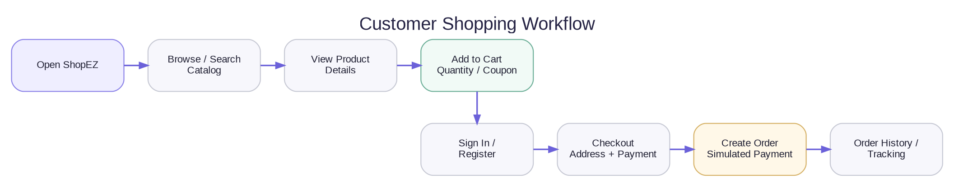
Figure 3. Customer workflow from browsing through order history.
Workflow Steps
1. Start: The customer opens ShopEZ and views the storefront.
2. Browse: The customer filters categories or searches for a product.
3. Inspect: The customer opens product details and checks description, price, and stock information.
4. Add to Cart: The customer adjusts quantities and may apply an eligible coupon.
5. Authenticate: The customer signs in or registers before protected checkout operations.
6. Checkout: The customer supplies shipping information and selects a payment method.
7. Order: The backend validates order inputs and returns an order response; payment processing is simulated in this project.
8. Track: The customer opens order history to see current status and available tracking information.
The admin workflow is separate: an administrator signs in, opens the protected management console, reviews KPIs, edits catalog entries, and changes order status. Route protection prevents ordinary customers from performing administrative API operations.

MVC PATTERN:
ShopEZ uses a decoupled single-page application architecture rather than a traditional server-rendered MVC application. The same conceptual separation can still be described using view, controller, and model responsibilities, but the view runs in React in the browser and communicates with Express through a JSON REST API.
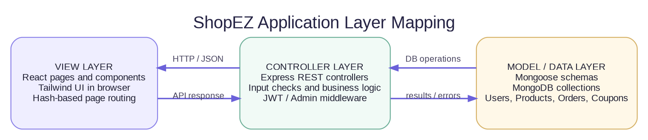
Figure 4. View, controller, and data-model responsibilities in the decoupled application.
View Layer
React pages and reusable components render the storefront, product detail, cart, checkout, customer profile, and admin console. Tailwind CSS supplies the responsive presentation; the browser router selects the visible page.
Controller Layer
Express controllers receive API requests, perform validation and business operations, invoke model/database methods, and return JSON responses. Authentication and admin middleware protect routes before controller logic runs.
Model / Data Layer
Mongoose models describe the User, Product, Order, and Coupon documents, including field constraints, references, and defaults. MongoDB persists records when a configured database is used; the project also reports an in-memory development fallback.
Benefits include separation of concerns, modular testing, reuse of API and data logic, and independent evolution of the React frontend and Express backend.

PROJECT SETUP AND CONFIGURATION:
The supplied source inventory identifies a root folder containing separate backend and frontend applications. Open the root in a code editor, check the README and package files, and use two terminal sessions so that the API and browser development server can run concurrently.
1. Project Structure
C:\ShopEZ\
├── package.json, package-lock.json, README.md
├── backend\ (Express API, models, controllers, tests)
└── frontend\ (React SPA, Vite configuration, pages and components)
2. Install Dependencies
cd C:\ShopEZ\backend
npm install
cd C:\ShopEZ\frontend
npm install
3. Start the Backend API (Terminal 1)
cd C:\ShopEZ\backend
npm run dev
The supplied instructions expect the API at http://localhost:5000. The database connector uses a configured MONGO_URI when available, otherwise the reported local fallback may start an in-memory MongoDB instance.
4. Start the Frontend (Terminal 2)
cd C:\ShopEZ\frontend
npm run dev
Open the local Vite URL shown in the terminal (reported as http://localhost:5173/). If startup fails, review the terminal logs and the README before changing dependencies or configuration. Do not commit .env files or any private secrets.

BACKEND DEVELOPMENT:
The backend is built with Node.js and Express.js. Its responsibilities include authentication, product catalog operations, coupons, order processing, analytics, request validation, and error responses. The supplied source-code inventory lists the following principal modules.
Backend Structure
backend/
├── package.json
├── .env.example
├── tests/
│ └── api.test.js
└── src/
├── server.js
├── config/db.js
├── controllers/
│ ├── authController.js
│ ├── productController.js
│ ├── orderController.js
│ ├── couponController.js
│ └── analyticsController.js
├── middleware/
│ ├── auth.js / authMiddleware.js
│ ├── admin.js
│ └── errorMiddleware.js
├── models/ (User.js, Product.js, Order.js, Coupon.js)
└── seeder/ (products.js, users.js, seeder.js)
Main Backend Responsibilities
• server.js: Configures Express, middleware, routes, and centralized error handling.
• Controllers: Separate authentication, product, order, coupon, and analytics operations.
• Middleware: Validates JWT identity, checks the administrator role, and handles error responses.
• Tests: The supplied test report identifies backend API tests in backend/tests/api.test.js.
Security-related packages listed in the audit include helmet, cors, bcryptjs, jsonwebtoken, dotenv, and morgan. The system should be deployed only with production-grade secret management and appropriately configured origins.

DATABASE DEVELOPMENT:
Database Connection
ShopEZ uses MongoDB as its document database and Mongoose as the Object-Document Mapper (ODM). The database connection logic is located in backend/src/config/db.js according to the supplied file inventory. When an external MONGO_URI is configured, the backend can connect to that database. The audit also reports mongodb-memory-server as a fallback for local development and automated tests when no URI is present.
Collections and Main Fields
• User: name, email, password hash, role, avatar, and createdAt. Email is reported as unique and normalized to lowercase.
• Product: name, description, price, category, brand, image URL array, stock count, rating, review count, and featured flag.
• Order: user reference, order items, shipping address, payment method/result, item/tax/shipping/discount totals, total price, paid flag, status, tracking number, and timestamps.
• Coupon: unique code, discount percentage, minimum purchase amount, expiry date, usage limit, times used, and active flag.
Schema Validation and Seeding
Mongoose schemas define data types, required fields, uniqueness and default values. Password handling uses bcryptjs according to the supplied audit. A seeder utility is listed under backend/src/seeder/ and the evidence reports eight seeded catalog products and demo customer/admin accounts.
The Order document contains embedded order-item subdocuments that reference Product records. A User can be associated with multiple Orders. Coupon rules are validated against purchase totals. The ER diagram on page 5 represents these major entities and the relationships described in the evidence.

FRONT-END DEVELOPMENT:
The frontend is a React 18 single-page application bundled by Vite and styled with Tailwind CSS. The supplied file inventory lists the following structure and responsibilities.
frontend/
├── package.json, vite.config.js, tailwind.config.js, postcss.config.js
├── index.html
└── src/
├── main.jsx, App.jsx, index.css
├── context/
│ ├── AuthContext.jsx
│ ├── CartContext.jsx
│ └── NotificationContext.jsx
├── services/api.js
├── components/ (Navbar.jsx, Footer.jsx, ProductCard.jsx)
└── pages/
├── HomePage.jsx, ProductDetailPage.jsx
├── CartPage.jsx, CheckoutPage.jsx, OrderSuccessPage.jsx
├── UserProfilePage.jsx, AdminDashboardPage.jsx
└── LoginPage.jsx, RegisterPage.jsx
Frontend Implementation
App.jsx dispatches routes using the custom hash router. AuthContext holds login/session state; CartContext manages cart calculations and coupon logic; NotificationContext supports toast notifications. The API service makes fetch requests and adds the Bearer token for authenticated calls. Product cards and page-level components separate reusable UI from feature-specific screens.
Testing Summary and Limitations
The supplied evidence records 24 passed tests out of 24 and a successful Vite production build. Payment transactions are simulated, email delivery is logged rather than dispatched through SMTP, and product images refer to external URLs. The browser captures for checkout and order confirmation show an empty-cart state and a loading indicator; those two screens require a fresh successful capture for stronger visual confirmation.

OUTPUT SCREENSHOTS:
Homepage
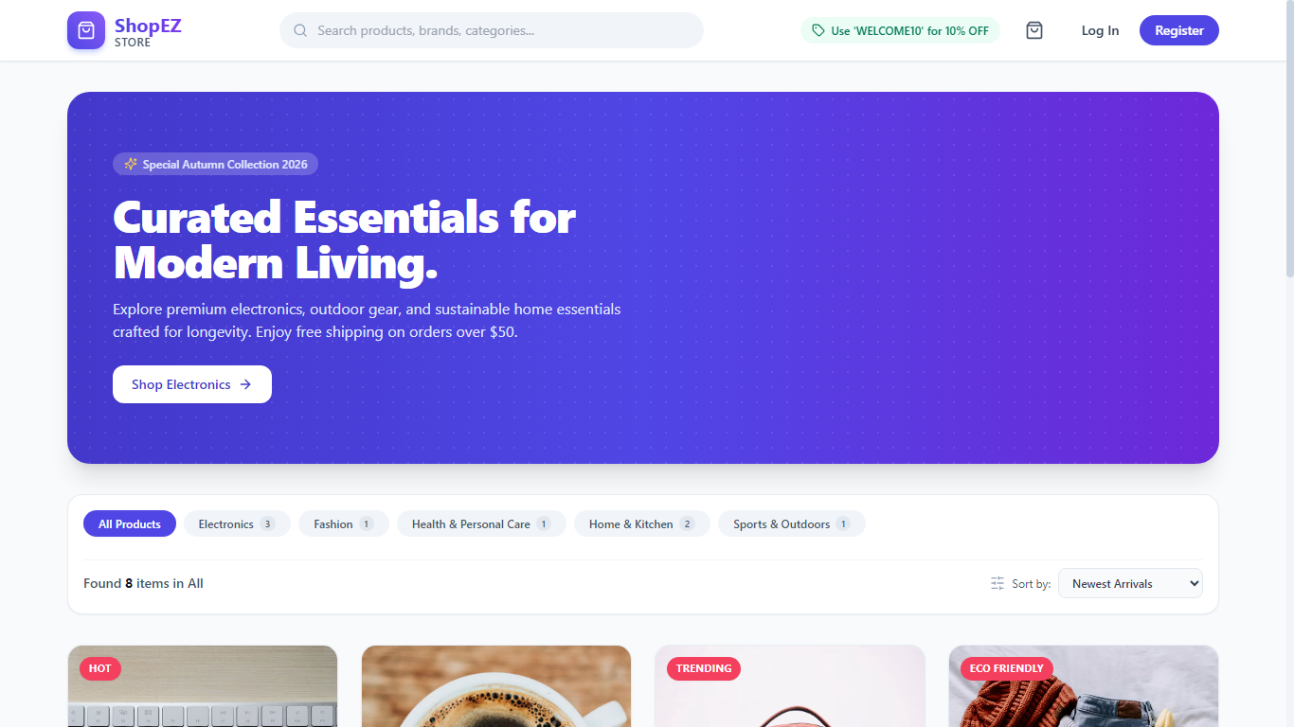
Figure 5. Homepage — storefront hero banner, category filters, and product grid.
Product listing
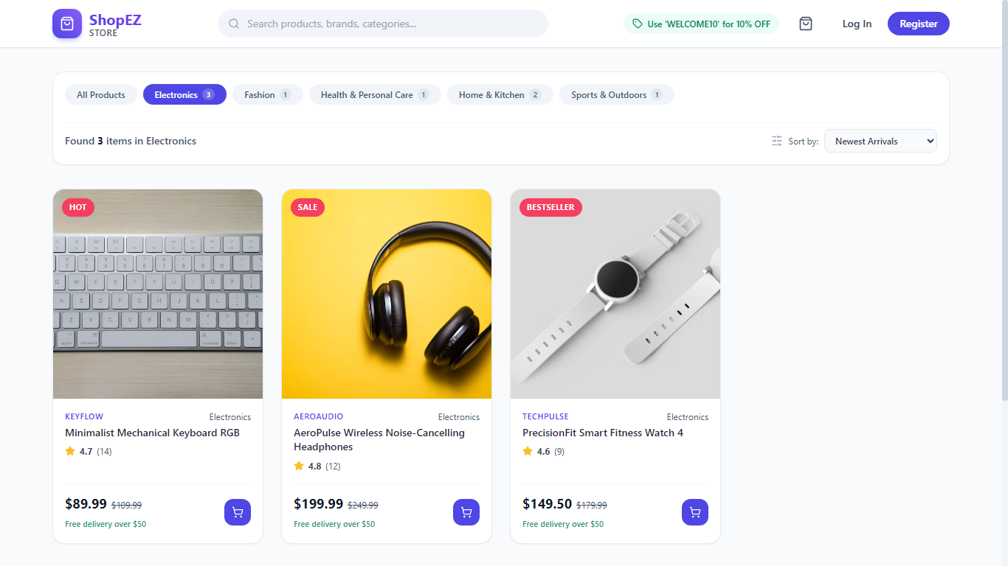
Figure 6. Product listing — catalog filtered by the Electronics category.

OUTPUT SCREENSHOTS (CONTINUED):
Search and filtering
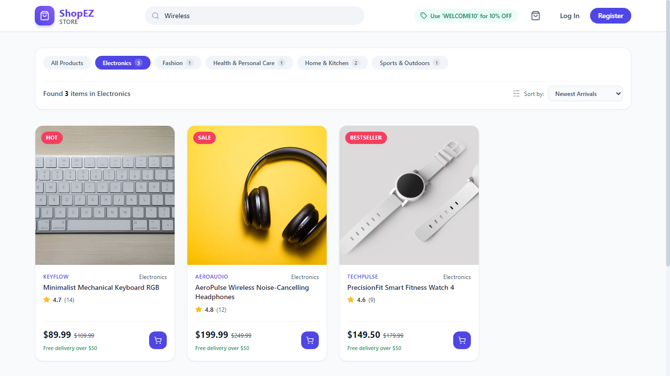
Figure 7. Search and filtering — matching catalog products for a keyword search.
Product details
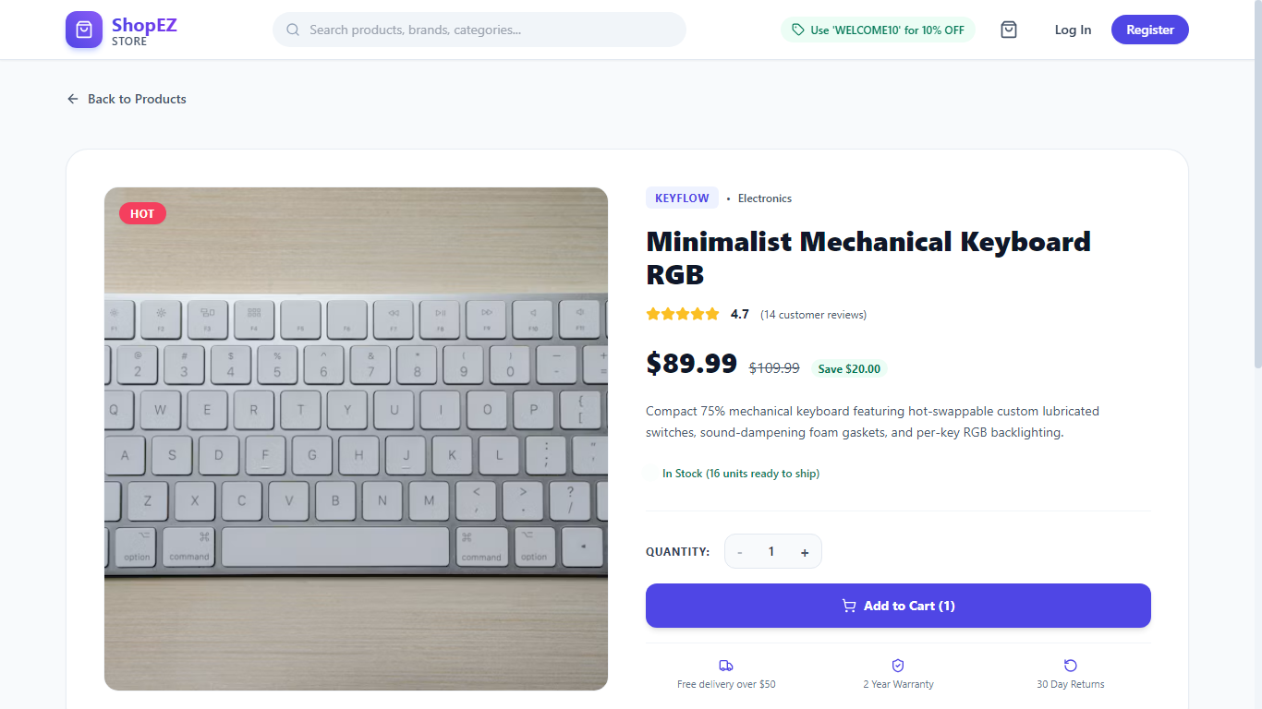
Figure 8. Product details — specification, price, ratings, stock information, and Add to Cart action.

USER ACCOUNT SCREENS:
Registration page
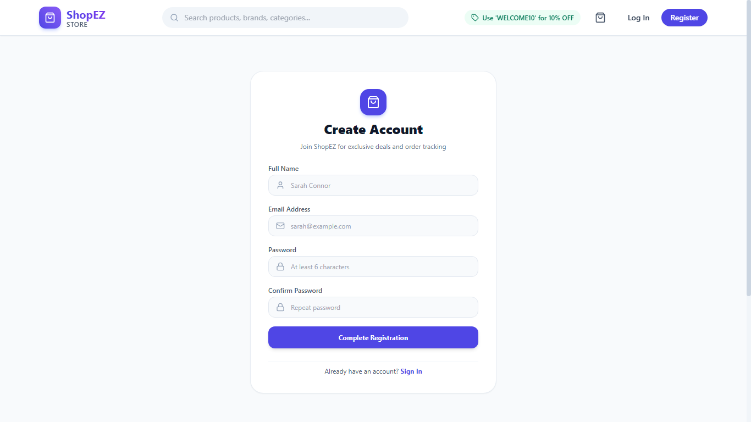
Figure 9. Registration page — customer account creation form.
Login page
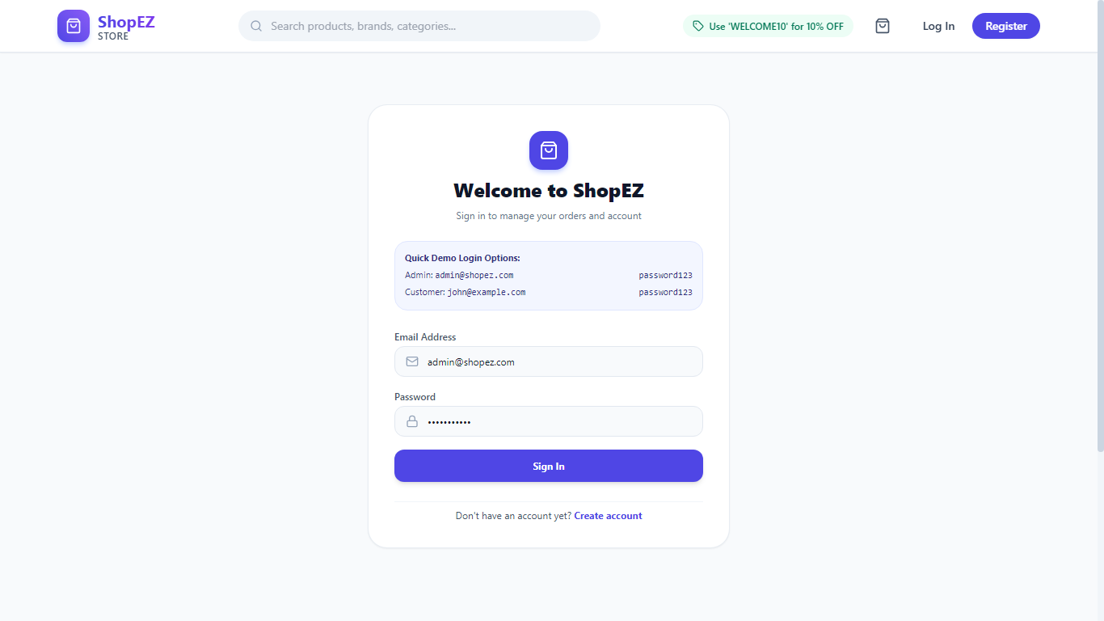
Figure 10. Login page — credential form and demo-account shortcuts.

CART AND CHECKOUT SCREENS:
Shopping cart
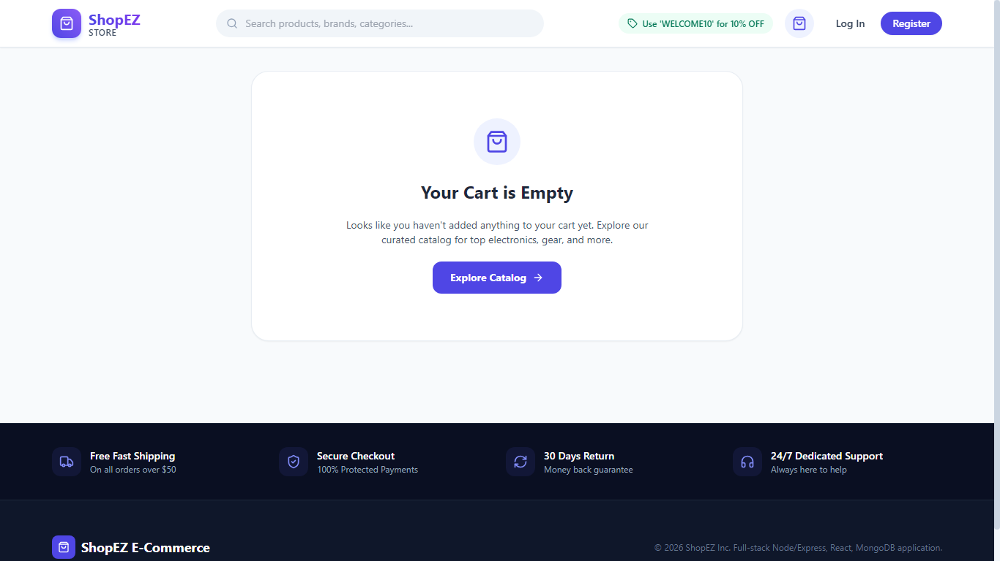
Figure 11. Shopping cart — cart state and displayed cart summary.
Checkout route
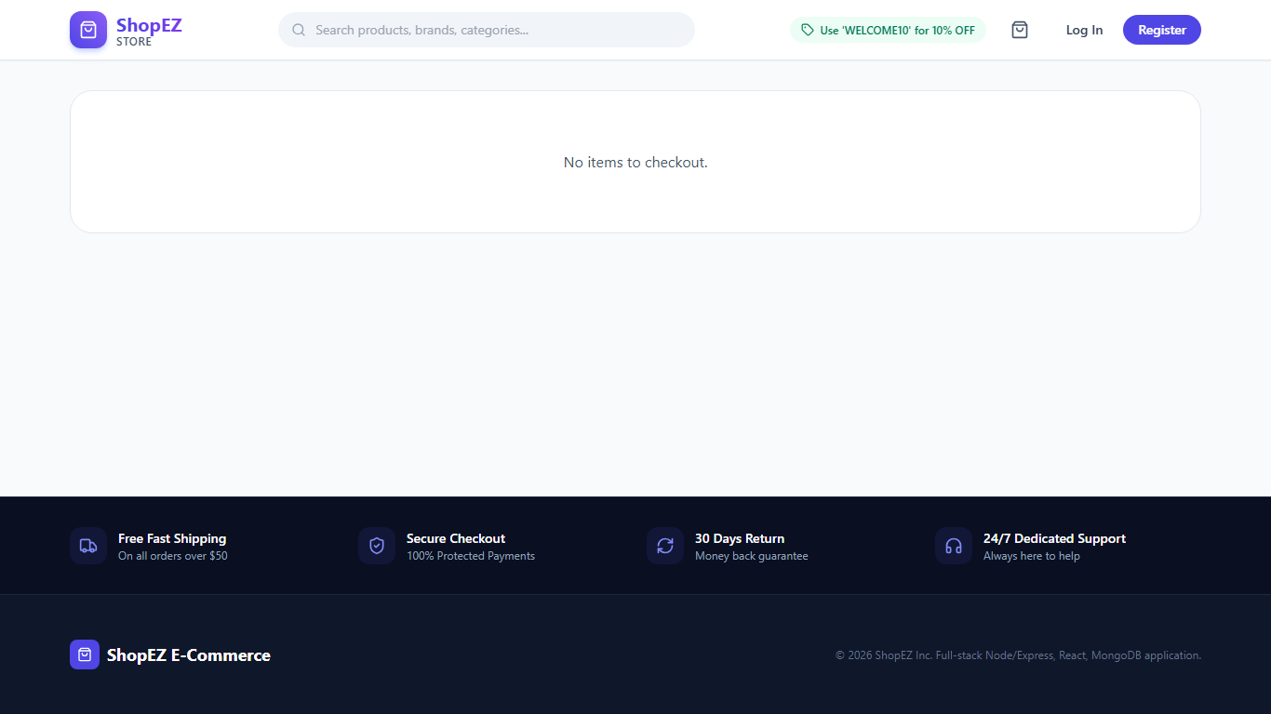
Figure 12. Checkout route — captured empty-checkout state.
Capture note: the checkout image shows an empty-cart message rather than a populated shipping/payment form. It is included as an honest record of the provided browser capture; this image does not, by itself, visually verify successful checkout submission.

ORDER SCREENS:
Order confirmation route
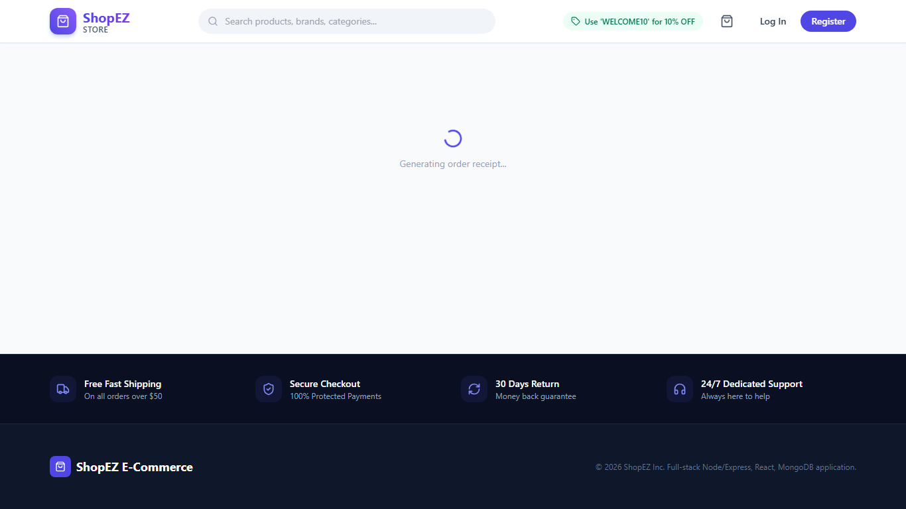
Figure 13. Order confirmation route — loading state visible during capture.
Order history
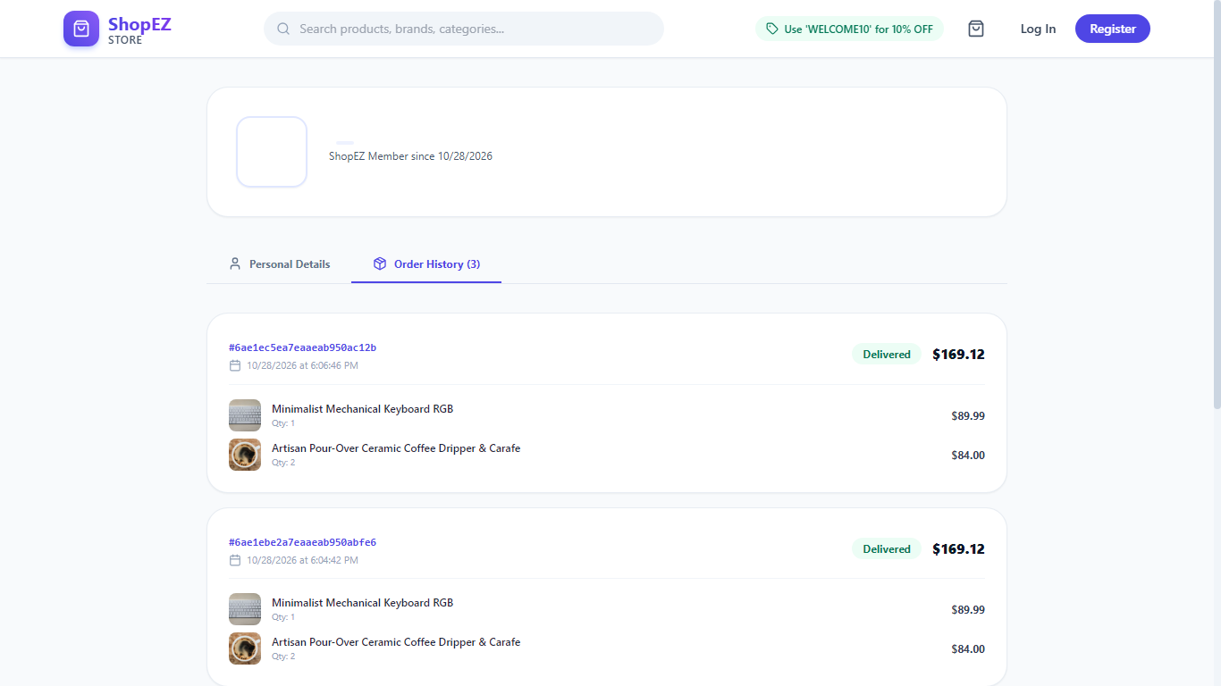
Figure 14. Order history — displayed past orders and fulfillment information.
Capture note: the order-confirmation screenshot remains on a loading indicator. The supplied API test report records order-placement and payment-simulation test results, but the final confirmation page is not visually verified by this capture.

PROFILE AND ADMINISTRATION SCREENS:
User profile
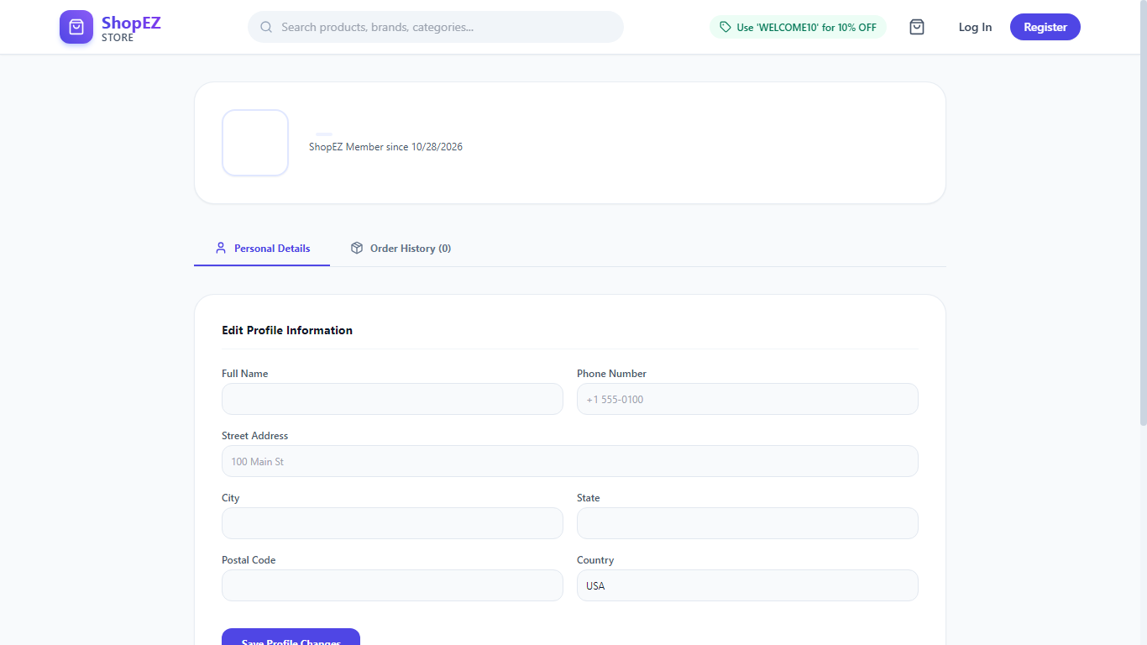
Figure 15. User profile — personal details and delivery-address controls.
Administrator dashboard
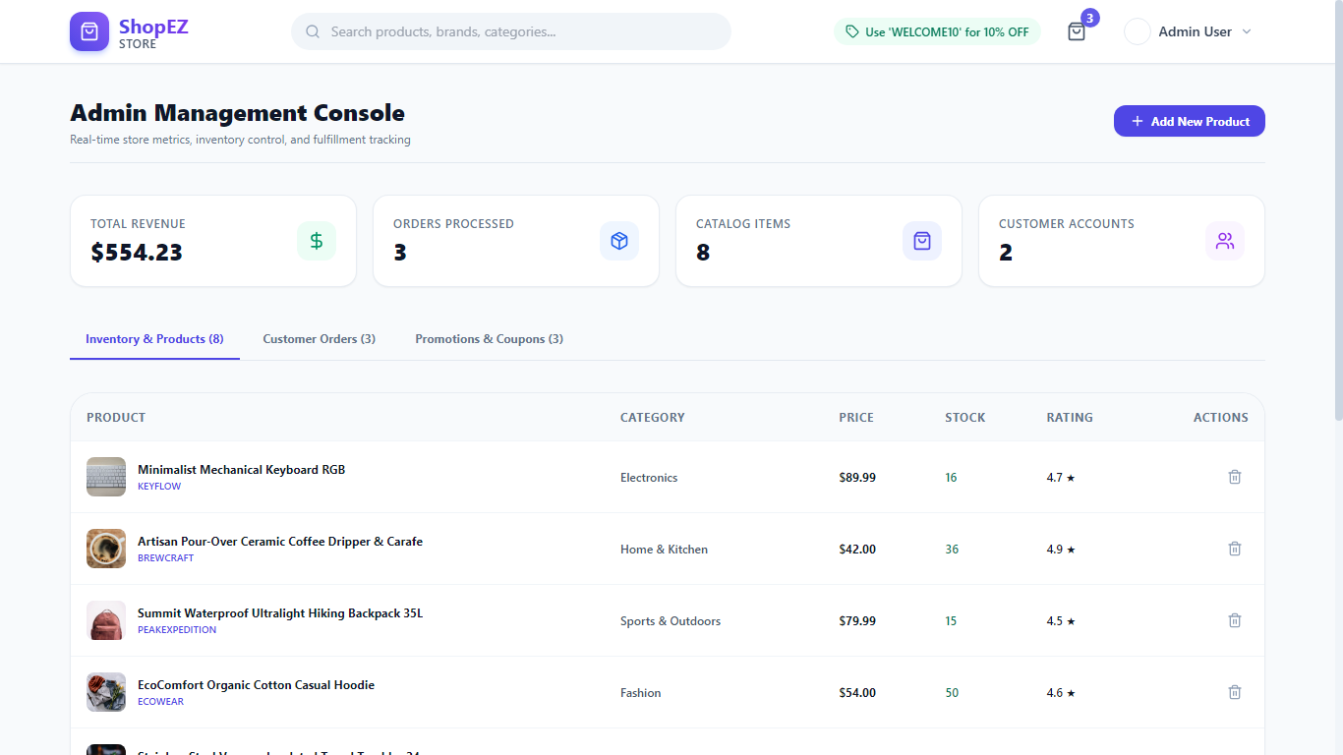
Figure 16. Administrator dashboard — KPI cards and store management overview.

ADMINISTRATIVE MANAGEMENT SCREENS:
Product management
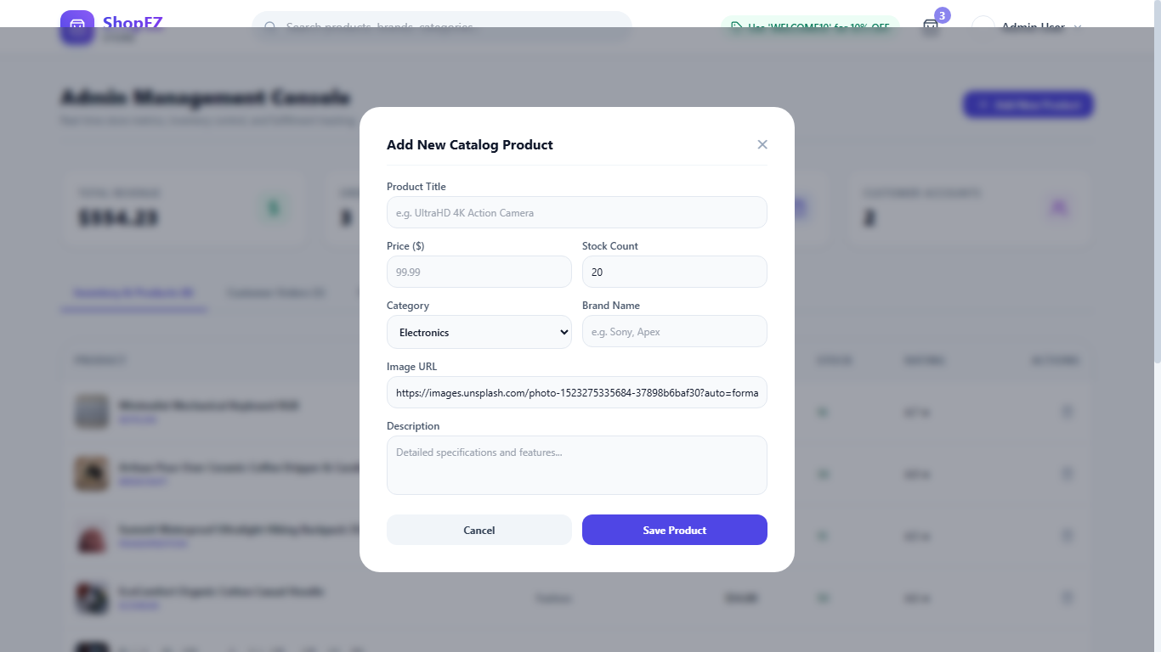
Figure 17. Product management — inventory table and Add New Product modal.
Order management
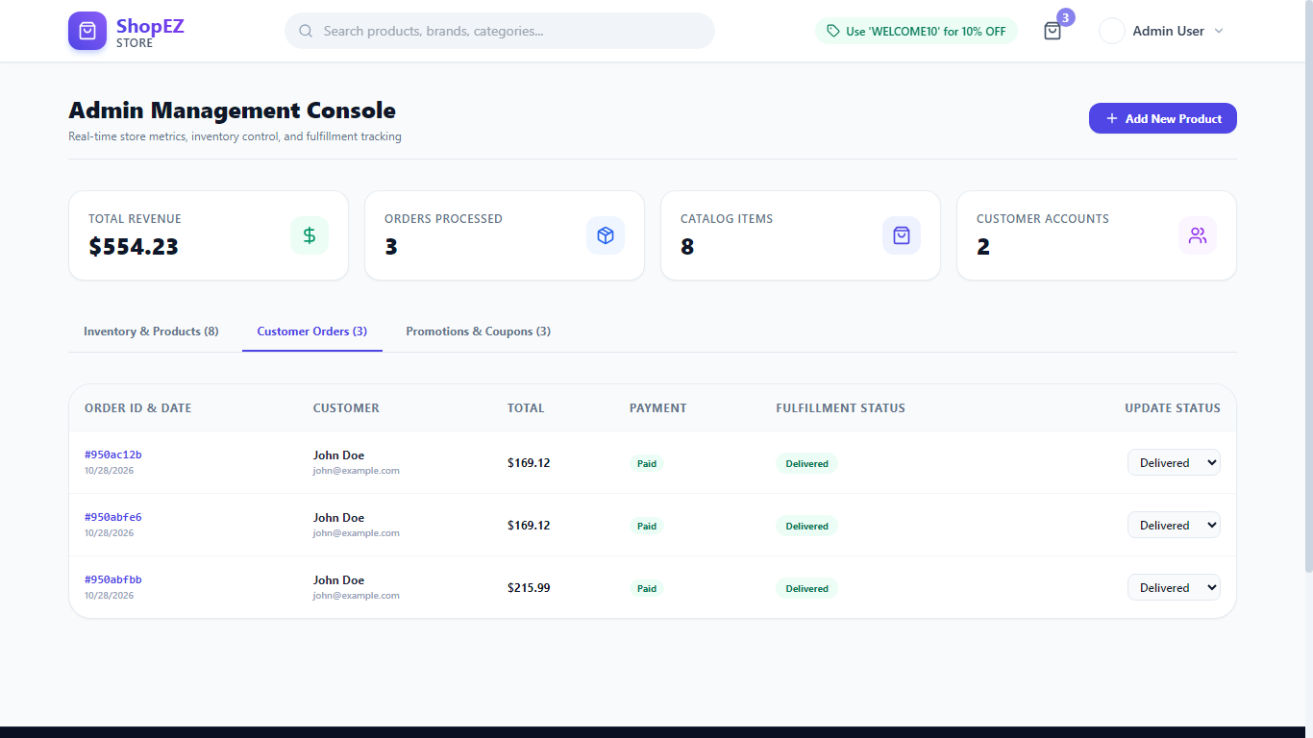
Figure 18. Order management — customer orders and status controls.

RESPONSIVE OUTPUT, TESTING AND CONCLUSION:
Mobile View
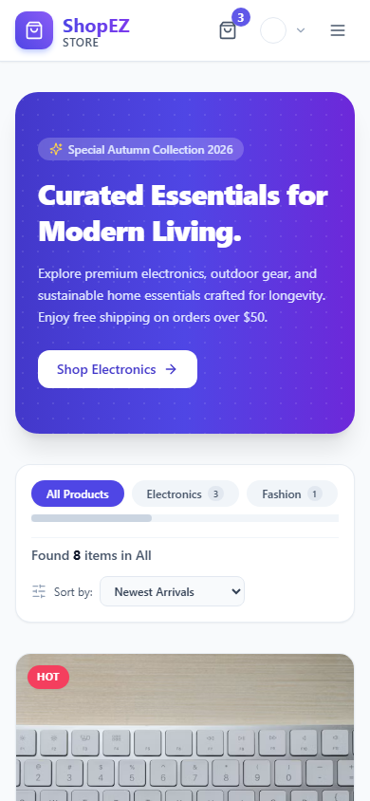
Figure 19. Responsive mobile layout captured at 390 × 844 pixels.
Testing and Verification Summary
The supplied test log records 24/24 backend unit and integration tests passing. Reported checks cover API health, registration, duplicate-email rejection, login, password validation, protected profile access, product retrieval, admin access restrictions, product creation/deletion, order creation, empty-order rejection, order history, simulated payment, order-status updates, coupons, and dashboard analytics. The supplied audit also reports a successful Vite production build.
Known Limitations
• Payment: External gateway processing is simulated; live Stripe/Razorpay webhooks are not verified.
• Email: Order and reset notifications are logged to the backend console rather than sent by a configured SMTP service.
• Product Images: The catalog references external image URLs rather than local multipart uploads or a dedicated object-storage service.
• Visual Capture: Checkout was captured with an empty cart, and the order-confirmation route was still loading. Recapturing those screens after a successful browser flow is recommended.
Conclusion
ShopEZ demonstrates a full-stack e-commerce workflow with a React frontend, an Express REST API, MongoDB/Mongoose data models, account authentication, product browsing, cart and coupon logic, order records, and administrative management. The supplied evidence indicates a successful automated API test run and frontend build, while the payment/email limitations and two incomplete browser captures should be resolved before describing those parts as production-ready.

